EXPERIMENTAL CORAL REEF MESOCOSMS ENRICHED IN MACROALGAE EXHIBIT MICROBIALIZATION.

A THESIS SUBMITTED TO THE GRADUATE DIVISION OF THE
UNIVERSITY OF HAWAI‘I AT MĀNOA IN PARTIAL FULFILLMENT
OF THE REQUIREMENTS FOR THE DEGREE OF

MASTER OF SCIENCE
IN
OCEANOGRAPHY

AUGUST 2026
By
Keanu G. Rochette-Yu Tsuen

Thesis Committee:
Craig Nelson, Chairperson
Nyssa Silbiger
Nicholas Hawco

Keywords: Microbialization, Phase Shifts, Microbial Communities, Biogeochemistry

© Keanu G. Rochette-Yu Tsuen

Acknowledgements

Dedications

Abstract
Bacterioplankton plays an essential role in the recycling of dissolved compounds in oligotrophic coral reefs, which support coral growth, productivity, and biodiversity in coastal tropical regions. In the recent decades, coral reefs have exhibited declining coral cover with concomitant increases in macroalgae. Continuous benthic surveys from the Moorea Coral Reef Long Term Ecological Research program illustrated that past predator outbreaks (Acanthaster planci), cyclones, marine heatwaves, and ongoing anthropogenic impacts are associated with phase shifts from coral to macroalgal dominance. The microbialization hypothesis proposes that phase shifts alters the benthic organic exudation, disrupting bacterioplankton community composition by favoring the growth of copiotrophic bacteria. Copiotrophes are less efficient at recycling carbon which causes carbon loss to higher trophic levels, decreased nutrient availability for coral primary production and growth, decreased dissolved oxygen, and increased risk of infection from potential pathogen growth. To test this hypothesis we designed mesocosm experiments simulating pre-disturbance (coral-enriched), post-cyclonic (crustose coralline algae-enriched), and post-marine heatwave (macroalgae-enriched) reefs to assess the effects of benthic communities on compositional dynamics of microbial communities and dissolved organic matter. We measured a suite of parameters over a 24h period to resolve how changes in benthic communities composition will alter dissolved organic matter composition and concentration (via fluorescence spectroscopy and high-temperature catalytic oxidation) and shift microbial community abundance and taxonomic structure (via flow cytometry and amplicon next generation DNA sequencing). Algal enrichment in benthic communities depleted nutrients, specifically nitrate+nitrite. Increased macroalgal abundance was also associated with the exudation of compositionally different fluorescent organic molecules, such as Coble C peak and fulvic acid, and resulting in changes in humic ratios (M:C ratio). Additionally, algae-enriched mesocosms exhibited greater abundant of heterotrophic bacteria with enrichment in copiotrophic genera such as Vibrio, Arcobacter, Neptuniibacter, and Roseobacter, while oligotrophic genera (Prochlorococcus, Marinimicrobia, Actinomarina, and Pelagibacter were depleted. The results of this project enhance our understanding of the interactions between coral reef benthic assemblages, bacterioplankton communities, and microbial processes, with implications on coral reef productivity, health, and resilience in the oligotrophic ecosystems of the South Pacific.

Table of Content
Acknowledgements iii
Dedications iv
Abstract v
1. Introduction 1
1.1. Ecological Phase Shifts in Coral Reefs Worldwide 1
1.2. Effects of Organic Exudation of Benthic Primary Producers on Microbial Carbon Processing 2
1.3. Exudate Composition Influences Microbial Community Structure 2
1.4. Mo’orea Coral Reefs: a Case Study of the Effects of Benthic Community Alteration on Coral Reef Biogeochemistry 3
1.5. Project Objectives 4
2. Methods and Materials 5
2.1. Site Description Overview 5
2.2. Benthic Organism Collection for Mesocosm Communities 5
2.3. Mesocosm Experiment Set Up 6
2.4. Water Sample Collection 7
2.5. Subsample Collection and Laboratory Analysis 8
2.5.1. Dissolved Organic Carbon (DOC) 8
2.5.2. Fluorescent Dissolved Organic Matter (fDOM) and Nutrients 9
2.5.3. Chlorophyll-a 10
2.5.4. Cell Abundance via Flow Cytometry 10
2.5.5. Bacterial Community Structure 11
2.6. Statistical Analysis 12
3. Results 14
3.1. Nutrients and Chlorophyll-a 14
3.2. Organic Matter Exudation Rates in Mixed Benthic Communities 15
3.3. Bacterial Abundance and Chlorophyll-a 16
3.4. Changes in Microbial Community Structure Associated with Mixed Benthic Community Exudation 19
4. Discussion 22
4.1. Benthic Community Composition Drives Treatment-Associated Patterns of Organic Exudation and Bacterial Community Structure 22
4.2. Organic Exudation and Composition are Driven by Benthic Community Assemblages 22
4.3. Composition of Organic Exudates Driven Microbial Community Structure 23
5. Conclusion 25
6. References 26
7. Supplemental Material 36

List of Figures

Figure 1: Mesocosm Experiment Setup. 7
Figure 2: Nutrient variations by treatment and sampling time. 14
Figure 3: Exudation of fluorescent DOM indices. 16
Figure 4: Cell abundance of heterotrophic bacteria and Synechococcus. 18

List of Tables

Introduction

Ecological Phase Shifts in Coral Reefs Worldwide
Coral reefs are dynamic tropical ecosystems that provide essential ecosystem services. Scleractinian corals form complex three-dimensional structures that provide habitats to diverse species of marine fauna and flora. Wave energy is rapidly dissipated in as a result of benthic rugosity which provide shoreline protection. Coastal communties have been relient on coral reefs as a source of sustenance since times immemorial with a recorded X% of the seafood consumed in nearshore communities each year in modern days. In indigenous coastal communities, where the marine environment has an intrisic spiritual and religious significance, marine resources have been used for cultural ceremonies, such as cleansing and forgiveness rituals. Coral reefs also represent a competitive economic asset as coastal areas have developed nautical activities for leisure and tourism, as well as the exploitation of fisheries for economic revenue (fish, sea urchins, pearl production etc...).
Anthropogenic disturbances are linked to coral reef degradation, resulting in phase shifts towards algal dominance (Bruno & Selig, 2007; Done, 1992).. Over the past decades, coral reefs have been in steady decline due to a combination of local and global factors. At the local-scale, proximity to human settlements has been correlated with greater algal cover in coral reefs (Barott et al., 2012). Land development, urbanization, and stream diversions have been linked to the loss of permeable surfaces, native forests, and the shortning of stream beds increasing run offs and sediment inputs in streams. Agricultural fields near the coasts or along large rivers are a source of pollutants such as pesticides, herbicides, and fertilizers in the aquatic systems. As a result, terrestrial run offs increased sedimentation and represent non-point source pollution in coastal waters which collectively, increase the sensitivity of corals to envrionmental pressures, further weakening the resilience of coral reefs. (Adam et al., 2021; McCook, 1999; Smith et al., 2006) (Bahr et al., 2015; Jones et al., 2019). Additionally, the over-exploitation of marine resources has caused detrimental ecological consequences on marine ecosystems. Chronic overfishing reduces grazing pressure on macroalgae and/or reduces top-down control on corallivorous fish which supports the proliferation of macroalgae in coral reefs (Carpenter, 1986; Lewis, 1986; Miller, 1998; Miller & Hay, 1998). Alteration of trophic dynamics had rippling effects on the marine food webs, i.e. trophic cascades, which can result in the collapse int the population of marine food sources without proper management.
At the global scale, sustained anthropogenic carbon emissions increase the frequency and intensity of detrimental stochastic events. Extreme events such as marine heatwaves, storms, and hurricanes can drive large scale coral mortality, which promote conditions ideal to induce coral-algae phase shifts (Glynn, 1993; Glynn & D’croz, 1990; Hoegh-Guldberg, 1999; Kleypas et al., 1999) (Edmunds et al., 2025; Palmer et al., 2025; Schmitt et al., 2019). Shifts in oceanographic regimes from global warming have also increased the frequency and intensity of cyclical events such as El Niño events which can induce large-scale bleaching and intense hurricanes resulting in additional coral mortality (Palmer et al., 2025). The degradation of coral reefs will only get more severe as a result of the combined effects of local pressures and climatic events, thus increasing the likelihood of ecological phase shift from coral to algae dominance in tropical reefs. Large scale alterations in coral reef bethic community assemblages have documented effects on the ecosystem functions of macro flora and fauna (Ainsworth & Mumby, 2015; Carpenter, 1986; Done, 1992; Trapon et al., 2011). However, the effects of phase shifts on water column processes have limited resolution and have potential implications on ecosystem productivity, health, and functions.

Effects of Organic Exudation of Benthic Primary Producers on Microbial Carbon Processing
Coral-algal phase shift changes the benthic community assemblages with consequences on carbon processing. Coral and macroalgae exude part of their primary production in the form of dissolved organic matter (DOM). Representing a rather large pool of carbon the ocean, DOM can be measured by proxy in the form of dissolved organic carbon (DOC) or fluorescent dissolived organic matter (fDOM). Labile DOM constitute the base of microbial food webs and microbial processes support coral reef productivity. The microbial loop recovers DOM and cycles it back into the food web, thus preventing carbon loss to the environment. Due to nutrient limitation in oligotrophic tropical oceans, microbial remineralization of DOM ensures the access of biologically available inoragnic nutrients to primary producers. As such, microbial process are essential in maintaining productivity, ecosystem function and biodiversity in coral reefs.
DOM exhudation and composition varies between corals and macroalgae. Benthic primary production represents a source of dissolved organic matter (DOM) in the water column with greater dissolved organic carbon (DOC) fluxes associated with algae compared to corals (Brocke et al., 2015; Haas et al., 2011, 2013). In isolation, macroalgae exuded magnitudes of DOC more compare to corals. In addition, the corals and macroalgae were associated with distinct pools of DOM (Haas et al., 2013; Nelson et al., 2013). DOM associated with macroalgal communities showed enrichment in labile carbohydrates (galactose and fucose), while coral exometabolites were enriched in aromatic amino acid molecules (Nelson et al., 2013; Quinlan et al., 2018). As a result, algae exudates were associated with greater abundance of microbes and distinct commmunity strutures compare to corals. Further investigation at the ecosystem level showed that corals and macroalgal produce exometabolites that are compositionally different in chemical classes and stoichiometry (Wegley Kelly et al., 2022).

Exudates of benthic primary producers influence microbial metabolism and microbially-mediated processes (Wegley Kelly et al., 2021). Algal exudates are rapidly consumed by heterotrophic microbes, resulting in greater growth rate, bacterial activity and abundance (Haas et al., 2011, 2016; Nelson et al., 2013; Quinlan et al., 2025).

However, despite rapid carbon consumption, algal exudates are associated with reduced microbial growth eﬀiciency which limits carbon recycling through the microbial loop with repercussions on abundance and biodiversity of higher trophic consumers (Nelson et al., 2023; Silveira et al., 2015).
The microbialization hypothesis suggests that coral-algal phase shifts would shift reef metabolism to microbial consumption and energy use. As corals and algae photosynthesize, they release different quantities and compositionally distinct pools of DOM, therefore feeding different taxa of microbes. This is thought to affect microbial proccesses which maintain productivity and health in coral reef ecosystems.

Exudate Composition Influences Microbial Community Structure
In oligotrophic coral reefs, exudated dissolved organic matter (DOM) constitutes the base of microbial food chains and bacterioplankton plays a critical role in the remineralization and trophic recycling of these dissolved molecules (Nelson et al., 2013; Tanaka et al., 2011; Wild et al., 2010). The analysis of metagenomic taxonomy of the 16S rDNA gene reveals that water column bacterial communities are coupled with the benthic ecosystem via DOM exudation. Evidence suggests that microbial community structure changes in response to variation in DOM composition, quantity, and quality, with repercussions on microbial diversity and abundance (Quinlan et al., 2018; Sparagon et al., 2024; Weber et al., 2022). Coral exudates have been associated with oligotrophic taxa, specifically, Alphaproteobacteria families (Erythrobacteraceae, Kordiimonadaceae, Hyphomonadaceae) (Haas et al., 2016; Nelson et al., 2013). On the other hand, algal exudates exhibit a greater association with copiotrophic taxa, e.g., Gammaproteobacteria families (Enterobacteriaceae, Vibrionaceae, and Pasteurellaceae) and Bacteroidetes (Cytophagaceae and Flavobacteriaceae) (Haas et al., 2016) some of which have a higher likelihood of carrying bacterial virulence factor genes (Nelson et al., 2013). As a result, alteration of bacterial communities could impact microbially-mediated carbon remineralization, nutrient recycling, and biomass transfer to higher trophic levels, with repercussions on coral feeding, photosynthesizing, calcifying, and pathogenesis (Morrow et al., 2012; Nelson et al., 2023).
------ Intergrate in section above -----
Interactions between the coral reef benthos, carbon fluxes, and bacterioplankton remain poorly understood in mixed benthic communities. Previous studies either used mesocosm experiments with isolated benthic organisms to measure the organic exudation and microbial metabolism (Brocke et al., 2015; Haas et al., 2011; Nelson et al., 2013), or in-situ surveys to associate net organic matter release and microbial communities in the coral reef ecosystem (Comstock et al., 2022, 2026 ; Haas et al., 2016 ; Nelson et al., 2011). Links between benthic primary producers and reef microbial metabolism have been investigated in lab and in situ measurements on isolated individuals (Haas et al., 2013). However, the effects of mixed benthic community assemblages on organic outputs, microbially mediated processes, and bacterial community structure in coral-algal phase shift conditions have not yet been tested.

1.X Caveats of current studies
However, current studies, specifically the seminal paper that do attempt to resolve the biogeochemical and microbial changes associated with phase shift, are not representative of the natural reef conditions. Indeed, Haas 2013 and Nelson 2013 have demonstrated DOC differences in quantities and composition leading to microbial community changes in incubation experiments of isolated individuals. This study does not encompass the complexity of coral reef ecosystems and does not account for diverse species assemblage/inter-species contribution of the DOM pool, thus providing a limited understanding of DOM exudation and microbial dynamics. Conversely, Haas 2016 compares different coral reefs systems in different oceans and on different territories resulting in potential confounding variables due to differences in oceagraphic regimes, variability of sampling, seasonilty and time passed between sampling compaigns…etc. In order to understand the specific changes associated with coral-algal phase shifts, we need better controlled conditions with reefs that are directly comparable, which can be achived by artificially recreating reef ecosystems in mesocoms.

Mo’orea Coral Reefs: a Case Study of the Effects of Benthic Community Alteration on Coral Reef Biogeochemistry
The island of Mo’orea, French Polynesia, represents an ideal location to address the gap in knowledge regarding coral-algal phase shifts induced microbialization. Decadal benthic surveys from the Mo’orea Coral Reef Long Term Ecological Research program (MCR LTER) have shown that reefs have exhibited a series of shifts in dominant benthic taxa with partial recoveries throughout its history (CITATION !). Long term surveys enabled the development of a well-informed hypothesis on the etiology of the coral-algal phase shifts occurring in Mo’orea: 2006 predator outbreaks of Acanthaster planci (Crown-of-Thorns seastar or taramea), 2011 cyclone Oli, and the 2019 marine heatwave (Kayal et al., 2012; Schmitt et al., 2019). Additionally, nearshore nutrient enrichment (John et al., 2025) and overfishing may facilitate macroalgae growth in their competition for space against corals (Adam et al., 2021; Schmitt et al., 2019). Understanding the implications of coral-algal phase-shifts in Moorean reefs would provide invaluable indights on the mechanistic onsets of microbialization, the magnitude of the biogeochemical changes, and the resilience of the ecosystem.

Project Objectives
In this project, we sought to understand the effects of the enrichment of selected primary producer taxa in mixed benthic assemblages on organic exudation and composition with subsequent effects on bacterioplankton abundance and community structure. We hypothesized that DOC production would be significantly greater in communities enriched in macroalgae with compositionally distinct DOM outputs. Consistent with the microbialization hypothesis, we expected to observe distinct bacterial communities associated with algal enrichment, with greater abundance of copiotrophic bacterial families. Additionally, inorganic nutrients (ammonia, nitrate, and phosphate) are hypothesized to be more depleted in algal communities, especially during the daytime, due to increased nutrient uptake associated with primary production.
To test these hypotheses, we designed a large-scale flow-through mesocosm experiment tracking dynamics of organic matter and microbial communities among reef assemblages representative of benthic community types found over the past two decades on the North Shore of Mo’orea: pre-disturbance (coral-enriched) communities were contrasted with parallel post-cyclonic (crustose coralline algae-enriched), and post-heatwave (macroalgae-enriched) communities. Over a 24-hour period the water column of these mesocosms was sampled every 6 hours to investigate coupled changes in organic exudations, bacterial abundance, and bacterial community structure. Results illustrate the effects of mixed communities on organic exudation, carbon processing, and microbial community dynamics with respect to the phase shift induced microbialization.

Methods and Materials

Site Description Overview
Mo’orea is a small volcanic high island (135 km²) located in the Society Islands of French Polynesia (17°30’S, 149°50’W) in the South Pacific. The island is surrounded by an extensive coral reef barrier, roughly 0.5 kilometer from shore, through which 12 reef passes allow seawater to flow between the lagoons and the open ocean. The inner side of the reef barrier represents a distinct shallow back reef habitat (about 3 m deep) where reef patches, separated by sand, coral rubble, and reef pavement, dominate the benthos (Leichter et al., 2013). In this study, we aim to characterize the biogeochemical and bacterial community changes associated with altered benthic ecology. Using benthic cover time series from the LTER program, we identified three ecological phases: a coral-enriched pre-disturbance reef (2006), post-cyclonic crustose coralline algae (CCA)-enriched reef (2011), and a post-marine heatwave algae-enriched reef (2019). We experimentally recreated the 2006, 2011 and 2019 reef assemblages, representing 3 treatments, in flow-through mesocosms using coral fragments, CCA, algae, sand, and coral rubble from the North shore back reef habitats of Mo’orea.

Benthic Organism Collection for Mesocosm Communities
Benthic organisms, especially corals, crustose coralline algae and macroalgae Turbinaria ornata were collected under permit # XXXXX in the back reef of the North shore of Mo’orea, in the Papetō’ai district (17°29’09.0”S, 149°52’42.6”W). Porites rus coral fragments, Turbinaria ornata, crustose coralline algae (CCA) (Porolithon onkodes and Hydrolithon sp.), coral rubble, and sand were collected on snorkel at 3 m depth. P. rus colonies (~15 cm in diameter, n = 24), Porolithon onkodes and Hydrolithon sp. were collected using a hammer and chisel. Whole T. ornata (~20 cm tall) was collected by hand at the substrate level (n= 52). Additionally, sand was collected using a hand trowel and bucket from the top 5 cm oxic layer of sediments. Samples were brought back in coolers to the Gump South Pacific Research station, located in Piha’ena, Mo’orea. The Gump Station is a University of California research station supported by the Long-Term Ecological Research (LTER) program which provides the necessary facilities for US researchers to conduct studies in French Polynesia.

Mesocosm Experiment Set Up
Mesocosms comprised of 11.4-liter clear polycarbonate aquaria (27.62 cm x 27.62 cm x 20.32 cm) that were previously leached in DI-water for 24h. Two holes were drilled into the side of the aquaria, about 13 cm apart, fitted with PVC pipes and nozzles that were fixed with PVC cement. PVC valves on each water outlet allowed measurement and control over the flow rate of the out-going water. Water flow rate was adjusted every five days by measuring the volume of water flowing out of the tank for a minute. Average outgoing flow rates of the aquaria were 5.86 ± 6.00 mL.s-1 for a mean aquarium residence time of XX. Aquaria were placed in flow through water tables equipped with overhead pipes to supply seawater from Paopao Bay (Cook’s Bay). Mesocosms aimed to recreate benthic cover of the reefs of Moorea based on 2006, 2011 and 2019 LTER data. The 2-dimensional planar benthic cover of the mesocosms was manipulated to replicate the percent cover recorded in the LTER time series fromt the years 2006, 2011, and 2019. Coral-enriched aquaria represented a pre-disturbance state (44% coral, 34% rubble, 18% sand, 2% CCA, 2% Turbinaria). CCA-enriched tanks represented reefs post-Acanthaster planci outbreak and post-cyclonic disturbance (15% coral, 34% rubble, 25% sand, 25% CCA, 1% Turbinaria). Algae-enriched aquaria represented contemporary conditions (5% coral, 55% rubble, 20% sand, 0% CCA, 20% Turbinaria) (Figure 1). In addition to our three benthic cover treatments, a seawater-only mesocosm was used as a control to distinguish natural seawater chemistry shifts from those caused by benthic assemblages. Sixteen independent mesocosms were randomly assigned to each of the 4 treatments among two flow-through seawater tables, each connected to an overhead supply line that provided seawater to individual mesocosms through separate tubing. Flow-through tables were located in a partially shaded mesocosm facility at the UC. Berkeley Gump Research Station. Circulation pumps (600 L/H) were placed in each aquarium to ensure water circulation and avoid deoxygenation.

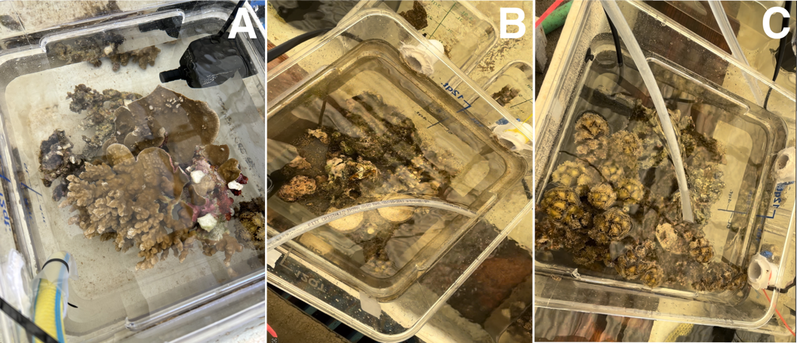
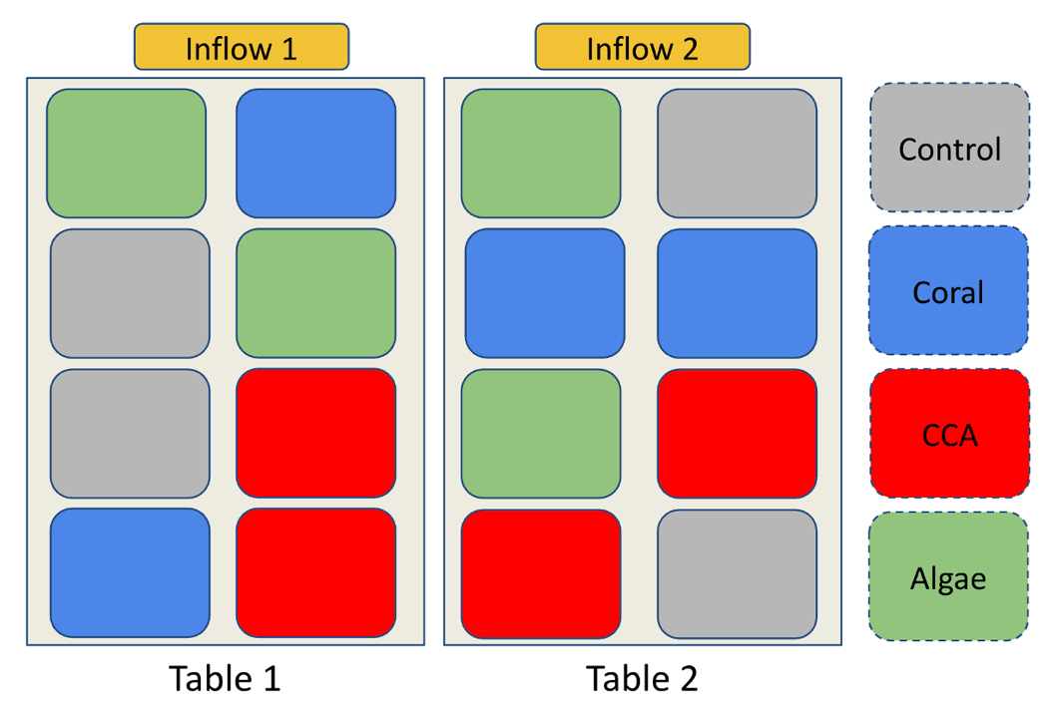
Figure 1: Mesocosm Experiment Setup.
(Top) Mesocosms containing benthic communities enriched in coral [A], crustose coralline algae (CCA) [B] and macroalgae [C]. (Bottom) Disposition of the 16 mesocosms on flow-through water tables.

Water Sample Collection
Throughout this experiment, we aimed to establish a comprehensive biogeochemical profile of the coral reef communities when exposed to our treatments. Using acid washed 1L polycarbonate bottles, we collected bulk water samples from the mesocosms every 6 hours over 24-hours, from June 2, 2024, 12:00 to June 3, 2024, 06:00 during the Austral winter. Various analytical subsamples were subsequently partitioned from these collections with different storage and preservation conditions. Each bottle was assigned to a specific mesocosm and only collected water from that aquarium. Bottles were triple rinsed with mesocosm water before bulk water collection. Water samples were also taken from the inflow pipes (the two water tables each had an independent overhead central inflow pipe from which water lines were connected to supply water flow to the mesocosms). Bulk water sample bottles collected from each aquaria were filtered via a Golander DG 6-12 peristaltic pump with pharmed peristaltic inserts and platinum-cured silicone transfer tubing; all tubing was acid leached and sample rinsed before collections. Subsamples were collected for dissolved organic carbon (DOC), fluorescent dissolved organic matter (fDOM) indices, nutrients (total nitrogen, nitrate, nitrite, ammonia, silicate and orthophosphate), water column chlorophyll-a, bacterial abundance, and bacterial metagenomic taxonomic structure.

Subsample Collection and Laboratory Analysis

Dissolved Organic Carbon (DOC)
Subsamples for DOC were pumped through 0.7µm, 25mm diameter Sterlitech Type F glass fiber syringe filters. Water lines were acid washed before filtration and were rinsed with mesocosm water before sample collection. Filtered water was stored in precombusted 24mL borosilicate vials, triple washed with filtrate, and acidified with hydrochloric acid (HCl 10%), then stored in the dark at room temperature. Samples were processed at the School of Ocean and Earth Science and Technology Laboratory for Analytical Biogeochemistry (S-LAB), University of Hawai’i at Mānoa. DOC was measured using a Shimadzu TOC-L Combustion Analyzer (detection limit of 4µg/L) via high-temperature catalytic oxidation using methods from (Carlson et al. 2010). A set of 8 DOC samples collected at midnight between 02 and 03 June 2024 were extreme statistical outliers greater than 2 standard deviations (70 µM) above the experimental mean (140 µM; n= 72) and were excluded due to contamination; other parameters collected at these timepoints were not outliers and were retained in the dataset.

Fluorescent Dissolved Organic Matter (fDOM) and Nutrients
Using the same pumping system, the Golander DG 6-12 peristaltic pump was aﬀixed with 0.22 µm Sterivex-GP pressure filters (Millipore Sigma). Filtered water for fDOM and nutrient measurement was collected in 50 mL polypropylene centrifuge tubes, triple-rinsed with filtrate prior to sample collection, and stored at -40°C. Samples were thawed 12 hours prior to fDOM measurements to allow them to come to room temperature. 1 cm quartz cuvettes were triple washed with DI water and wiped dried with Kim wipes. 3 mL of sample water was aliquoted in the cuvette and placed in a Horiba Aqualog scanning fluorometer. The cuvettes were triple rinsed with DI water in between samples. Samples were measured in groups of 7 with a DI water blank measured in-between groups. Data processing was performed using methods and scripts from Nelson et al. (2015). Excitation-Emission matrices (EEMs) were generated using excitation values every 5nm from 240nm to 500nm, and emission values measured continuously via CCD ranging from 250 nm to 825nm integrated over 4 sec at each excitation increment. Inner filter correction was applied to account for fluorescence quenching by absorbance (Kothawala et al., 2013). Fluorescence values were divided by the integrated emission range of 381nm to 426nm at an excitation of 350 nm in averaged DI water blanks to scale the measurements to Raman Units (Lawaetz & Stedmon, 2009). An average blank EEM was calculated from DIW blanks run before and after each set of samples and subtracted from each set of 7 sample EEMs. Lastly, informative biogeochemical indices were calculated, such as, UV-Humics (Coble A), Visible-Humics (Coble C peak), and tryptophan-like (Coble T) (Coble, 1996), fulvic acid (FI) (McKnight et al., 2001), and humic indices (BIX and HIX) (Huguet et al., 2009). After the fDOM measurements, water samples were returned to the freezer for storage at -40°C before being used for nutrient measurement. Nitrate plus nitrite (detection limit 0.006 µmol/L), orthophosphate (detection limit 0.012 µmol/L), silicate (detection limit: 0.116 µmol/L), and ammonia (detection limit 0.013 µmol/L) were measured with UV detection using the SEAL AA500 segmented flow injection nutrient analyzer following methods from (Kealoha et al., 2025).

Chlorophyll-a
The peristaltic pump was fitted with 0.45 µm HAWP nitrocellulose filters (MF-Millipore) and 250 mL sample water was filtered. The filters were frozen in aluminum foil at -40°C in the field lab, then stored -80°C for long term storage at the University of Hawai’i. The chlorophyll was extracted from the thawed filters by dissolving the filters in 5mL of 90% acetone for 6-8h in borosilicate vials. During the dissolution period, the capped vials were stored in the freezer. Samples were allowed to warm to room temperature 30 min before measurements. Chlorophyll-a fluorescence was measured using the Turner Design 10 AU fluorometer. Acetone solutions were loaded in the fluorometer to measure fluorescence at 680 nm. Final chlorophyll-a concentrations were calculated using the calibration curve of the SLAB which accounts for the filtrate and solvent volumes.

Cell Abundance via Flow Cytometry
1 mL of mesocosm seawater was sampled using a pipette with disposable tips and fixed with paraformaldehyde for a final concentration of 0.5% v/v in 2ml screw cap centrifuge tubes and kept at room temperature for 1-2h until being flash-frozen at -40C with subsequent long-term storage at -80°C at the University of Hawai’i for long term storage. Samples were processed at the Biological Electron Microscope Facility (University of Hawai’i at Mānoa) using a Beckman-Coulter CytoFLEX S flow cytometer. Once thawed and brought to room temperature, 275µL samples were aliquoted to polystyrene 96-well U-bottom plates and stained with 7µL of Hoescht 34580 dye (40µg/µL) for a final concentration of 1µg/µL. Additionally, distilled water blanks (stained and unstained) were added to each sample run. Samples were kept in the dark to stain for 30 min prior to being analyzed in the flow cytometer as per Selph (2021). Samples were drawn from each well at a rate of 60µL/min for 75 seconds, excluding the events of the first 15 sec to avoid cross-contaminations between wells.
Cell count was determined via hierarchical gating which separated events by size, DNA stain, and pigment-associated autofluorescence. The first gating separated the events in “low” and “high” chlorophyll content. Background events were determined by comparing bacterial counts in samples and blanks, and then removed from the sample events. Low-chlorophyll events were classified as heterotrophic bacteria while high-chlorophyll events were further divided by forward scatter. Large high-chlorophyll events were categorized as pico-eukaryotes while smaller events were labeled as picocyanobacteria. Cyanobacteria were sorted by phycoerythrin (PE) content with high PE cyanobacterial events corresponding to Synechococcus, and low PE cyanobacterial events were labeled as Prochlorococcus. Cell density (gated events per µL) was calculated by standardizing the event counts to the volume processed included in the event gating (60 µL).

Bacterial Community Structure
Sterivex filters used to collect nutrient and fDOM samples were frozen dry at -40°C in the field laboratory, then subsequently returned to the University of Hawai‘i and stored long term at -80°C. The 0.22 µm polyethersulfone filters were retrieved aseptically from the casing and placed in bead tubes (MP Biomedicals FastDNA™ Garnet Matrix). DNA was extracted at the University of Hawai’i Microbial Genomics and Analytical Laboratory (MGAL) using a Machery-Nagel NucleoMag microbiome kit on a ThermoFisher KingFisher Flex system. The V4 region of the 16S rRNA gene amplification following protocols from the Earth Microbiome Project (Caporaso et al., 2018) using forward-indexed primers 515F-Parada (5’-GTGYCAGCMGCCGCGGTAA-3’) and 806R-Apprill (5’-GACTACNVGGGTWTCTAAT-3’) (Walters et al., 2016). Minor modifications to the protocols were made such that triplicate reactions were not pooled and a standardized volume of 1µL of genomic template was used for amplification. The SequelPrep kit (Thermo Fisher Scientific) was used to clean and normalize the amplicons to equimolar concentrations. Samples were then pooled and sequenced using the Illumina MiSeq platform (600 cycle V3 chemistry). Sequences were demultiplexed using a probabilistic script; microbiome profiling was executed through the MetaFlow|mics pipeline (Arisdakessian et al., 2020) using settings from Jani et al. (2021). Sequences were assembled, denoised and trimmed using DADA2 and aligned with mothur to the Silva(v132) global SSU rRNA alignment database (Callahan et al., 2016; Schloss et al., 2009; Yilmaz et al., 2014). We used bayesian consensus classification to assign taxonomy strings to the sequences (70% confidence) to the genus level, and clustered into 97% sequence identity operational taxonomic units (OTU) using VSEARCH (Rognes et al., 2016; Wang et al., 2007). OTUs were refined to reduce intragenomic taxonomic splitting errors using LULU (Frøslev et al., 2017). Sequences that could not be classified at the “Domain” level as well as Mitochondrial and chloroplast 16S sequences were discarded. The sequencing depth was then standardized to 10,000 random reads per sample. Bioinformatics data was processed on the C-MAIKI gateway at the University of Hawai i at Mānoa (Cleveland et al., 2022). After data processing, OTU that were not greater than 0.1% abundance in at least one sample were filtered out of the data set.

Statistical Analysis
To test the hypothesis that algal communities change DOC production, DOM composition, nutrient consumption, and bacterial abundance compared to the control, we ran linear mixed effects models with DOC, fDOM, nutrient measurements and bacterial abundance as our dependent variables. Data processing and statistical analysis were performed using R (version 4.5.2) and RStudio (Posit Software, Boston, MA) (RStudio Team, 2022). For each variable, values that were outside of the $\overline{x}±2σ$ ranges were identified as outliers. The biogeochemical measurements were relativized to the average value of the inflow at the time of sampling, i.e., for each variable, values measured at each inflow line (one directed to each of the two experimental tables – Figure 1) were averaged first, then all aquaria concentration measurements were relativized by subtracting the averaged inflow value from the aquarium measurements. Linear mixed-effect models (package lme4 in R) were run using relativized data as a dependent variable, treatments of control, coral, CCA, and algae as independent variables with a sample time interaction term, and aquaria ID number as a random effects variable to account for repeated measures. Least squares linear regression of relativized concentration against log-transformed flow rate showed no significant flow rate effects on any variables (Supplemental Table 6.1). As such, log-transformed flow rates were added as a predictor in linear mixed-effect models for robust statistical modeling. For models that had a significant fixed treatment effect, we used a Dunnett’s post hoc test to determine contrasts (Lenth et al., 2026). Figures were created using the ggplot2 and patchwork packages (Pedersen, 2025; Wickham, 2016).
To investigate the bacterial community changes, we ran a PERMANOVA model using adonis2() from the package vegan (Oksanen et al., 2026). We used the weighted Unifrac distance matrix generated from the MetaFlow|mics pipeline with treatments, sampling time point and the log10-transformed flow rate as model predictors. We also accounted for treatment-time interactions, and repeated measurements using the aquaria ID number in the “strata” argument. Bacterial community changes were visualized in NMDS plots using the vegan package. The relative abundance of bacterial genera was displayed on a heatmap created with Complex Heatmap to display enrichment patterns and to cluster bacterial taxa in modules that had similar enrichement patterns (Gu et al., 2016). Bacterial taxa were simplified to exclude rare genera which had a summed abundance less than 0.5% in at least 3 samples. The relative abundance of abundant taxa was summed in each samples, square-root transformed, and z-scored before being plotted on a heatmap. Module membership was extracted from the heatmap. The relative abundance of each module was summed in each sample and modeled statistically to understand the effects of treatment and time on enrichment patterns. To understand changes in microbial community structure, we eventually ran linear mixed-effects models and Dunnett’s post-hoc test for each bacterial genus to identify specific microbial taxa which are sensitive to the effects of treatment and time in our experiment.

Results

Inorganic Chemistry
Relativized concentrations of orthophosphate, nitrate, ammonia, and silicate were measured as the difference from mean intake values at each of 4 timepoints (every 6h) over a diel 24h period (Figure 2). All nutrients significantly differed among sampling time points (Supplemental Table 1). Silicate exhibited significant differences among treatments (F_{treatment}= 4.41, p<0.05) that changed through time (F_{treatment:time}= 2.31, p<0.05), while the other nutrients did not show significance (p_{treatment} > 0.05). Post-hoc Dunnett’s contrasts showed a significant depletion of silicate between the CCA-enriched treatment and seawater control (p<0.05). Tukey’s post hoc test showed significant differences between 12:00 (T_{initial}) and the other three time points (p<0.05). Results suggest that net nutrient dynamics of orthophosphate, nitrate, and ammonia were independent of benthic community composition and sampling time. However, silicate exhibited variations driven by CCA-enrichment that are time dependent.
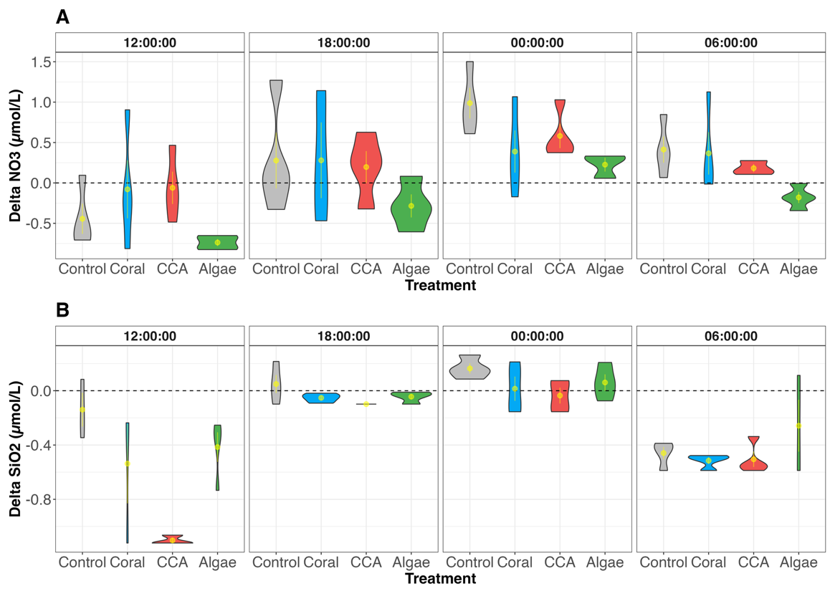
Figure 2: Nutrient variations by treatment and sampling time.
Variations in measured nutrient values are driven by the sampling time.

Organic Matter Exudation Rates in Mixed Benthic Communities
Over the course of the 24h incubation period, bulk DOC and fDOM-derived indices were measured to assess whether the organic exudation varied among mixed reef assemblages and across the diel sampling period. Linear mixed effect models showed contrasting patterns between DOC and fDOM components. Bulk DOC concentrations did not differ significantly among community treatments (F = 2.33, p = 0.09). However, characterized forms of DOM, including coble C peak fluorescence (coble C), coble M:coble C ratio (M:C ratio), fluorescence index (FI), and humification index (HIX), showed significant treatment effects (Coble C: F= 4.79, p<0.05; M:C: F = 12.2, p<0.05, FI: F= 4.38, p<0.05), and HIX: F= 4.27, p<0.05). Models showed neither time effects nor treatment:time interactions in any organic carbon measurements. Dunnett’s contrasts against seawater controls showed that algae-enriched treatments were associated with significant enrichment of coble C index (p = 0.02) and depletion of M:C ratio (p = 0.0002), and fulvic acid (p=0.02). Additionally, M:C ratio was significantly depleted in CCA-enriched treatments (p = 0.0012). Although HIX varied significantly across treatment, there was no significant difference between treatments and controls. Taken together, results show that bulk DOC exudation did not change significantly across mixed reef communities. However, algae-enriched communities exhibited a compositionally distinct pool of humic-like exudates relative to the seawater control, independently of sampling time.
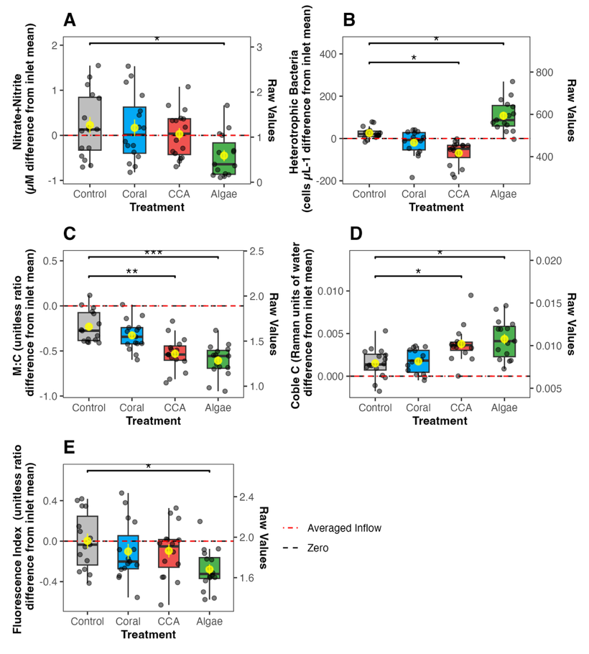

Figure 3: Exudation of fluorescent DOM indices.
fDOM exudation by treatment and across a diel cycle show increased production of Coble C and decrease measurements of FI and M:C ratio in algae-enriched communities.

Bacterial Abundance and Chlorophyll-a
We measured cell counts of heterotrophic bacteria, pico-eukaryotes, Synechococcus, and Prochlorococcus, and water column chlorophyll-a concentration to assess the effects of mixed reef communities on microbial abundance across a diel sampling period. Heterotrophic bacteria and Synechococcus exhibited significant treatment effects (Heterotrophic bacteria: F= 13.7, p <0.05; Synechococcus : F= 9.44, p <0.05), while pico-eukaryotes (F= 2.03, p = 0.16, Prochlorococcus (F=1.50, p=0.26) and chlorophyll-a (F=1.69 , p=0.22) did not show treatment related variations. Sampling time has significantly influenced the abundance of all microbes and chlorophyll-a concentration (p_{time} <0.05), however, there was no significant time interaction with observed treatment effects (Supplemental table XXX). Post-hocTukey’s HSD contrasts showed a significant increase of Synechococcus between 12:00 and 18:00 (p <0.01), Prochlorococcus between 12:00 and 00:00 (p = 0.002), and pico-eukaryotes between 12:00 and 06:00 (p < 0.01), while chlorophyll-a decreased significantly between 12:00 and 00:00 (p <0.01). No significant pairwise differences were detected across time points in heterotrophic bacteria. Dunnett’s post hoc contrasts highlighted a significant depletion of Synechococcus and heterotrophic bacteria in CCA-enriched communities compared to controls (p<0.05). Additionally, heterotrophic bacteria were significantly enriched in algae-enriched treatment compared to seawater controls (p<0.05). Collectively, mixed reef communities affect the abundance of microbes, specifically, depleting Synechococcus and heterotrophic bacteria in CCA-enriched reefs, and enriching heterorophic bacteria in algae-enriched communities. Sampling time also significantly affects microbial abundance without affecting patterns associated with treatment effects with lowest abundance at 12:00.

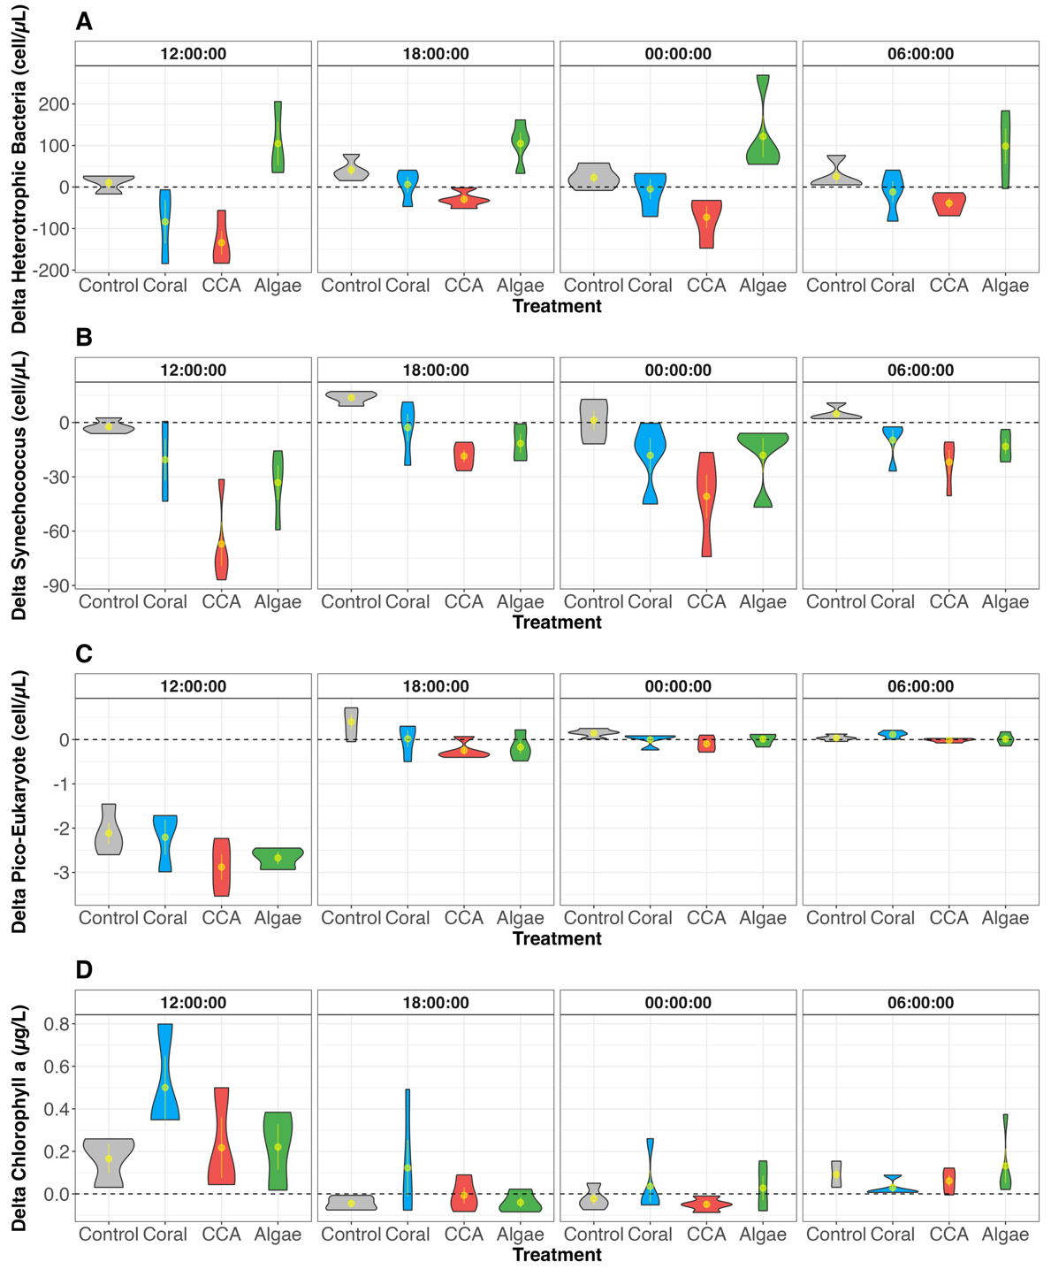
Figure 4: Cell abundance of heterotrophic bacteria and Synechococcus.
Violin plots of the abundance of bacterioplankton show increased heterotrophic bacte-ria cell count and decreased Synechococcus cell count in algae-enriched commu-nities across sampling time point

Changes in Microbial Community Structure Associated with Mixed Benthic Community Exudation
Microbial DNA was sampled every 6h over 24h to assess whether mixed benthic assemblages, would drive compositional divergence in bacterial communities relative to the seawater control. Non-metric multidimensional scaling (NMDS) plots from weighted UniFrac distances show microbial communities associated with algae-enriched communities were visually separated from other treatment groups at later night timepoints (00:00 and 06:00) (Figure 5). PERMANOVA showed significant variation among treatments (F= 3.73, df= 3, R² = 0.13, p= 0.001) and through time (F=5.06, df=3 , R² = 0.17, p= 0.001 ) with no signifcant interactions between treatment and sampling time point effects (F= 1.12, df= 9, R² = 0.12, p= 0.222). Microbial communities changed throughout the duration of the experiment as demonstrated by the significant effect of the sampling time (F= 5.06, df= 3, R² = 0.17, p<0.05). Algae communities and seawater control exhibited significant pairwise PERMANOVA (F = 5.24, df = 1, R² = 0.15, p<0.05), adjusted with Benjamini-Hochberg method, while coral and CCA enrichment did not show significant difference in community structure from the controls (Control vs. Coral: F =0.304, df = 1, R² = 0.010, p=0.987; Control vs. CCA: F =0.296, df = 1, R² = 0.0098, p=0.987).
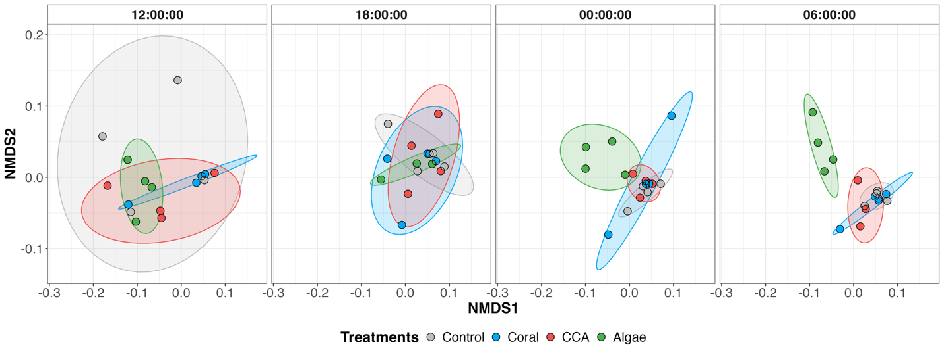
Figure 5: NMDS plots of bacterial communities by treatment across four sampling time points.
Each variable column shows time over 24h passing from left to right, starting at 12:00 until 06:00. Control, coral and CCA communities show similar community composition, while the algae-enriched microbial community structure diverges over time. (NMDS stress = 0.123).
Bacterial communities were further examined at the genus level to determine an association between benthic composition and microbial community structure. We were specifically interested in variations of relative abundance in bacterial taxa across mesocosm treatments and over the four sampling time points in chronological order (Figure 6). Taxa were split into three modules (modules A, B and C) via k-means which grouped taxa with similar patterns of enrichment and depletion. Module B showed significant treatment effects (F= 5.32, p=0.02) while modules A and C did not (module A: F= 3.23, p = 0.06; module C: F = 0.46, p = 0.71). Models showed significant time effects in Module A (F=578.6, p<0.05), B (F= 604.3, p<0.05), and C (F=29.9, p<0.05), as well as flow rate effect (module A: F=25.8, p<0.05; module B: F=31.1, p<0.05; module C: F= 42.5, p<0.05). All modules were associated with significant treatment:time interactions (module A= F127.1, p <0.05; module B: F= 284.1, p <0.05: module C: F= 39.1, p <0.05). Additonally, Dunett’s post-hoc contrasts indicated a significant enrichment of taxa in module B between algae-enriched treatments and the seawater control (p=0.03) (Figure 7).
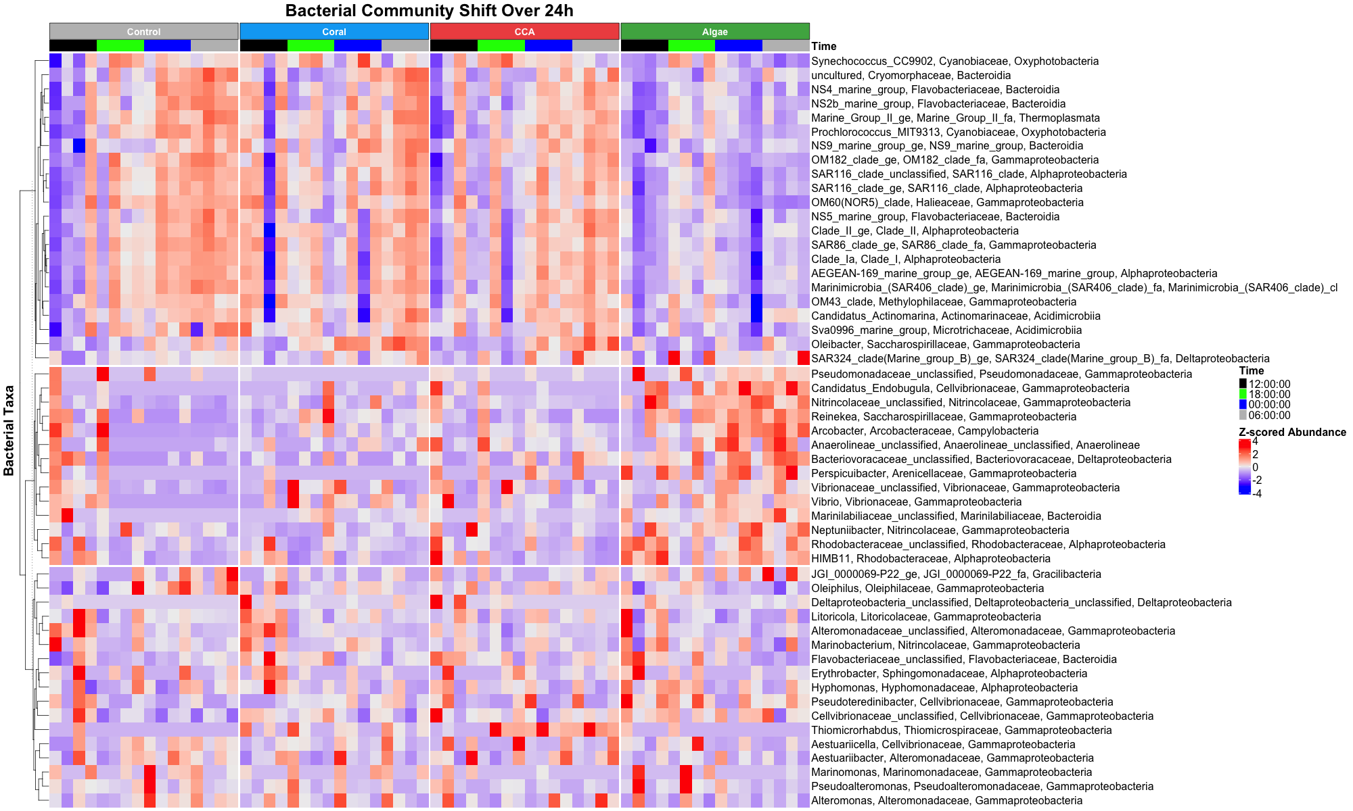
Figure 6: Heatmap showing significant differences in bacterial families across treatment.
Bacteria genera with similar enrichment patterns were clustered in the same module. Three modules can be observed: module A shows bacteria enriched in controls, coral, CCA-enriched treatments, module B shows bacteria enriched in algae-enriched treatments, module C shows microbes that do not have a treatment preference.

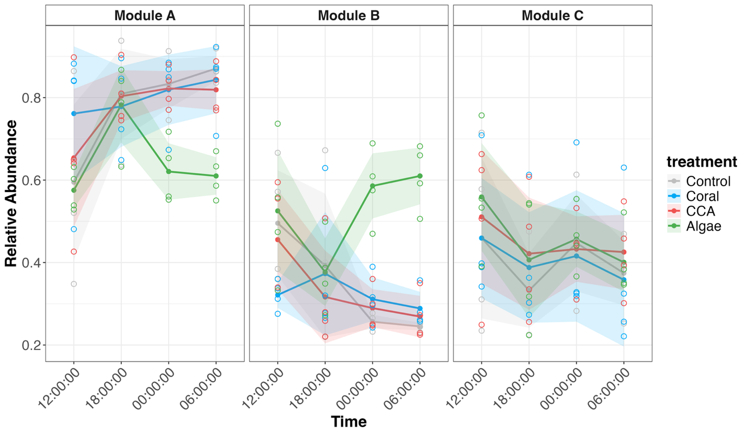

Figure 7: Modules
The relative abundance of bacterial genera were agregated by module and by treatment. Relative abundance curves show depletion of module A microbes and an enrichement of module B microbes in algae-enriched treatments.

The relative abundance of bacterial genera were relativized to the average inflow value at each time point to model enrichment and depletion patterns in each treatment. 23 bacterial genera showed significant ANOVA (p_{treatment} <0.05). Among those 23 genera, 15 genera exhibited significant Dunett’s post-hoc contrasts between control and treatments, specifically in algae-enriched treatments. As a result, algae treatment were associated with the significant enrichment of 6 genera and the depletion of 9 genera (p<0.05). Specifically, within Module A, the most abundant taxa were Synechococcus (mean 15.1%), SAR11 Clade Ia (mean 2.3%), SAR86 (mean 2.2%) and Procholorococcus (mean 2.2%). Of the 22 prevalent genera shown in module A, six were significantly depleted in the algae-treatment relative to the control (Supplementary Table 7). These key taxa have experienced a decrease from the controls by the end of the 24h sampling: SAR116 (-1.9%), SAR406 (-0.57%), OM182 (-0.34%), OM60 (-1.4%), Prochlorococcus (-1.9%), and Marine Group II genus (-4.5%) (Figure 6). Collectively, the results suggest that bacterial community structure diverges from the controls when benthic communities are enriched in macroalgae.

Discussion
Coral-algal phase shifts associated with coral reef degradation have been hypothesized to induce microbialization in coastal tropical ecosystems. In this study, we aimed to characterize the coupled inorganic and organic chemical transformations between benthic communities and the water column, as well as microbial community structure in response to biogeochemical stimuli from benthic exuduations. Mixed benthic communities were associated with divergent nutrient consumption, exudate composition and microbial abundance. Additionally, algal enrichment strongly influenced the composition of bacterial community structure in our experiments.

Benthic Community Composition Drives Treatment-Associated Patterns of Organic Exudation and Bacterial Community Structure
When comparing the biogeochemical measurments, organic exudation or bacterial abundance did not show large variations over a 24h diel cycle. fDOM indexes, specifically Coble C and HIX, as well as the humic ratio of M:C, have been particularly responsive to the treatment effects without varying significant over time. Similarly, abundance of heterotrophic bacteria and Synechococcus was primarily driven by benthic assemblages rather than sampling time. In comparison, nutrient concentrations experienced greater variations over a 24h diel cycle. Orthophosphate, nitrate, ammonia, and silica exhibited significant diel variations between 12:00 and 06:00 which can be attributed to alternating photosynthetic activity during daylight and respiration at night. As such, observed patterns in organic exudations and bacteria abundance can be primarily attributable to changes in benthic community composition rather than diel dynamics.

Organic Exudation and Composition are Driven by Benthic Community Assemblages
Results from our experiment have demonstrated that different mixed benthic communities do not significantly affect bulk DOC exudation but are rather linked to the exudation of compositionally distinct organic molecules, which did not show diel variation. Algae-enriched assemblages exhibited a preferential exudation of humic-like compounds which is consistent with organismal exudation results reported by Quinlan et al. (2018) and Wegley Kelly et al. (2021). Unlike those previous studies we did not observe an enrichment in proteinaceous fDOM in coral-associated treatments, suggesting that the mixed assemblages used here dampened that signal through rapid recycling of proteinaceous compounds. Although our results align with current literature, the scope of our methodologies lacks the resolution that targeted and untargeted mass spectrometry provide in analyzing exudated organic compounds (Quinlan et al., 2025; Weber et al., 2022; Wegley Kelly et al., 2021). Metabolomic surveys can provide invaluable insight on the interactions between benthic components such as allelopathy and chemical competition, especially during coral-algae competitive interaction, with implication on coral microbiome alteration, tissue degradation, and coral mortality (Barott et al., 2012; Morrow et al., 2012; Rasher & Hay, 2010; Smith et al., 2006).
Nevertheless, this study represents an important next step toward building controlled mixed community mesocosm models of tropical coral reefs. Results contribute to a mechanistic understanding of bentho-pelagic coupling and the onset of microbialization in tropical coral reefs. Our mesocosms represent a simplified subset of coral reef communities in Mo’orea and additional benthic constituents should be accounted for to establish a comprehensive profile of tropical reef exudation and their contribution to coral reef microbialization. Specifically, turf algae were identified as large contributors to the DOC exudation pool in mesocosm experiments and increase in abundance in degraded reef conditions (Haas et al., 2011; Mueller et al., 2022; Palmer et al., 2025). Still, because our community exudation results recapitulate and/or are consistent with more reductive single-organism exudation profiles conducted in this same ecosystem (Haas et al., 2011, 2013; Nelson et al., 2013; Wegley Kelly et al., 2021), this experiment reinforces interpretation of dissolved organic matter distribution patterns across these coral reefs (John et al., 2025; Silbiger et al., 2025) (Silbiger 2025, John 2025) as being significantly influenced by benthic exudation and thus responsive to changes in benthic cover.

Composition of Organic Exudates Driven Microbial Community Structure
Algae-dominated reefs exhibited elevated heterotrophic bacteria abundance (Dinsdale et al., 2008; Haas et al., 2016) and our results and others suggest elevated humic-like DOM exudation. Exudation experiments have shown visible differences in the composition of coral and macroalgal exometabolomes with macroalgae releasing DOM enriched in specific carbohydrates (Nelson et al., 2013; Thobor et al., 2024), prenol lipids, benzenoids and heterocyclic compounds (Quinlan et al., 2025; Wegley Kelly et al., 2021). Additionally, algal exudates have been associated with greater microbial metabolic activity (oxygen demand) but less eﬀicient growth rate (carbon yield) (Haas et al., 2011; Nelson et al., 2013; Thobor et al., 2024). Taken together these field observations and experimental results support the hypothesis of microbialization in degraded reef conditions (Nelson et al., 2023; Silveira et al., 2017). The results of this experiment represent an important experimental validation of some of the predictions of this hypothesis, showing that slight enrichments in algal dominance in mixed benthic community assemblies can reproduce observations in DOM and microbial communities predicted by microbialization, including increased humic DOM, bacterioplankton abundance and copiotrophic bacterioplankton taxa.
Microbial community structure associated with algae-enriched treatments shifted strongly over the 4 time points and was significantly different than the seawater control within 12h of initiation of the experiment. This finding is consistent with previous incubation experiments where microbial communities showed significant differences based on their exposure to coral and algal exudates (Haas et al., 2011; Nelson et al., 2013). Algae-enriched communities were depleted in oligotrophic genera of bacteria, consistent with previous studies which showed an enrichment in copiotrophic bacterial taxa in algal exudates (Haas et al., 2016). In place of oligotrophic genera, algal enrichment was associated with bacterial genera in the families Rhodobacteraceae which have been widely reported enriched on algal exudates (Nelson et al., 2013; Quinlan et al., 2025; Weber et al., 2022), and Nitrincolaceae and Cellvibrionadaceae which have been detected in coral microbiome under stress conditions such as hypoxia, disease or heat stress (Howard et al., 2023; Montaño-Salazar et al., 2023). As such our results reinforce that algal exudates restructure bacterial communities away from oligotrophic specialists.

Conclusion
The preservation of coral reefs is an urgent conservation priority as corals have been steadily declining due to anthropogenic forcings and global climate change. Our findings show that macroalgal enrichment in coral reefs did not change the exudation of bulk DOC but rather altered the composition of organic exudates which was linked to an increase in heterotrophic bacteria anundance, and a decrease in cyanobacteria (Synechococcus). Macroalgal enrichment is also associated with distinct bacterioplankton communities which are depleted of oligotrophic bacterial taxa due to enrichment in copiotrophic bacterial families found under phase shift, heat stress, disease, and/or hypoxic conditions. Developing a mechanistic understanding of coral-algal phase shifts and coral reef microbialization is essential to understand the resilience of coral reefs and their capacity to recover from disturbances, but also to identify coupled systems which may be impacted by biogeochemical changes, e.g., water quality, disease ecology, ecosystem productivity, and food web transfers. Insights from this study are particularly relevant for tropical coastal communities that rely on marine resources for sustenance, cultural practices, and economic development. Understanding the intricacy of microbially mediated processes is an important consideration for the development of management plans at the local level but also for regional and global conservation efforts. Further investigations on the composition of the benthic exudates and the bacterial metabolic pathways involved in the degradation of exudates are necessary to better understand biogeochemical cycling under coral-algal phase shifts worldwide.

References
Automatic citation updates are disabled. To see the bibliography, click Refresh in the Zotero tab.

Supplemental Material

Table 1: ANOVA Results of Nutrient Delta

Table 2: ANOVA Results of Square root-transformed OTU relative abundance

Table 3: Dunnett's Post-hoc contrasts square root transformed OTU relative abundance

Table 4: ANOVA Results of Delta Relativized OTU relative abundance

Table 5: Dunnett's Post-hoc contrasts delta relativized OTU relative abundance

Table 6: ANOVA Results of Square root-transformed Genus relative abundance

Table 7: Dunnett's Post-hoc contrasts Square-root transformed Genus relative abundance with signficant ANOVA

Table 8: ANOVA Results of Delta Relativized Genus Relative Abundance

Table 9: Dunnett's Post-hoc contrasts delta relativized Genus relative abundance

